**Numerical example of KNN in SPSS**

This section gives an example to show the application of K-Nearest Neighbor algorithm in SPSS. The chosen dataset contains various test scores of 30 students. So, on the basis of these scores, K Nearest Neighbor test can be used to find the nearest neighbor for ‘application status’. In this case the variable ‘status’ has only two values; 1- hired and 0- not hired.

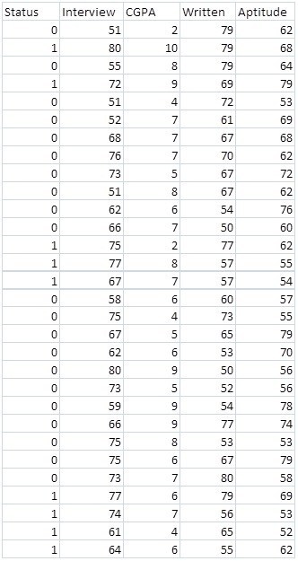

Table 1 Data set used for **KNN** test in SPSS

As discussed above, the **KNN** test uses the nearest value to predict the target variable. For example the value of the point shown in the figure below can be predicted (marked in red).